Practical - 9
WEB DEVELOPMENT FRAMEWORKS (ITUE203)
SEMESTER: 3RD, 2026-27
ID: 25DCE110

Practical Title: Secure User Registration with Database Insert, Duplicate Email Check, and Password Hashing.
Implement secure user registration by inserting user details into MySQL using MYSQLi. Validate input on frontend and backend, check duplicate email/username, hash passwords using password_hash(), and display appropriate messages.

Theory
- Is password_hash() used before storing passwords?
Yes. The password_hash() function hashes the user's password before storing it in the MySQL database. This helps protect passwords from being stored as plain text.
- Is duplicate email/username checked?
Yes. Before inserting a new user, the PHP backend checks whether the email or username already exists in the database. If a duplicate is found, registration is rejected and an appropriate message is displayed.
- Are frontend and backend validations consistent?
Yes. Frontend validation using HTML and JavaScript provides immediate feedback, while backend PHP validation checks the submitted data again before database insertion. Backend validation is essential because frontend checks can be bypassed.

Implementation/ Output/Result
Tags:
- • HTML form → collects user registration details.
- • JavaScript validation → checks input fields before submission.
- • PHP backend → validates the submitted data.
- • Duplicate check → prevents an existing email or username from being registered again.
- • password_hash() → securely hashes the password.
- • MySQLi prepared statement → inserts user details into the users table.
- • Response message → displays registration success or an appropriate error.

Output Screenshots:
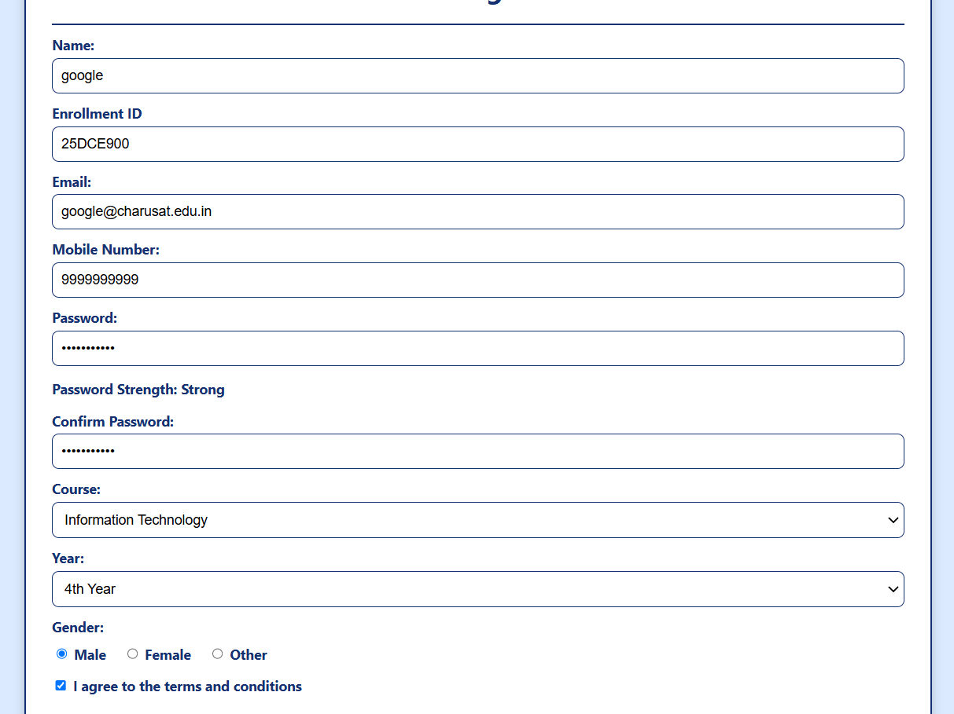
New student successfully registered:
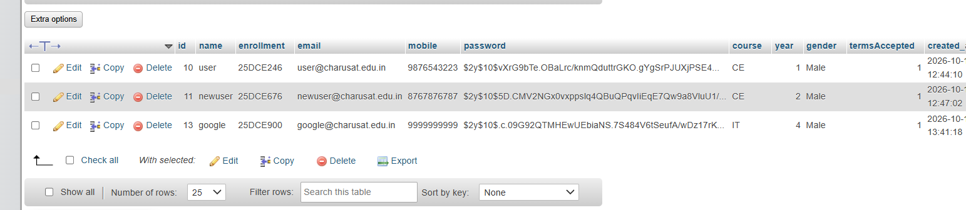

GitHub Repository Link:

https://github.com/kanan2007s-sys/Web-development-/tree/main

Challenges Faced:

The main challenges faced while performing this practical were connecting PHP with the MySQL database and implementing secure user registration.

Learning Outcomes:
Learned to implement secure user registration using PHP and MySQLi with input validation, duplicate checks, password hashing, and prepared statements.

Faculty Remarks:

